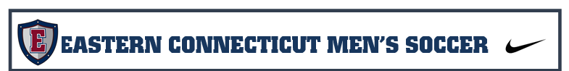
KEEPERS AND DEFENDERS |  | MIDFIELDERS |  | FORWARDS
Murphy | Cullinane |  |  | Fazzino | Grant
D’Ambrosio | Caicedo | Manfredi | Pakalnis | Trotman | Jensen
Neuendorf-CLASS | Sylvester | Stearns | Warren | Doran | Zeppieri
Lombardo-CLASS | Rattet | Tobon* |  | Jones
Traxler—INJ
Topic: Technical Functional Training Date 3/31/16
